**Azure secure score:** Azure Secure score helps you prioritize and triage your response to security recommendations by assigning values to the recommendations that can most help improve your security posture.

Secure score is a security analytics tool that provides visibility of your organization’s security posture and helps to answer the most important question, “how secure is my workload?” Secure score takes into consideration the severity and the impact of the recommendation. Based on that information, it assigns a numerical value to show how fixing this recommendation can improve your security posture.

Applicable for PaaS, IaaS, hybrid and multi-cloud workloads.

## **Secure Score in Microsoft Defender for Cloud**

[Secure Score](https://docs.microsoft.com/en-us/azure/security-center/security-center-introduction) is all about helping you improve your security posture with regards to your Azure resources (IaaS & PaaS) and even hybrid and multi-cloud workloads (i.e. AWS and GCP resources). When you select Secure Score in Microsoft Defender for Cloud it shows you a list of security controls, where each security control has a list of recommendations (see*Figure 1*). As you start addressing each one of those recommendations and you successfully address all the recommendations in a particular security control, your Secure Score will increase by a certain number of points (highlighted in the Potential score increase column). With your Secure Score increasing, your security posture will improve.

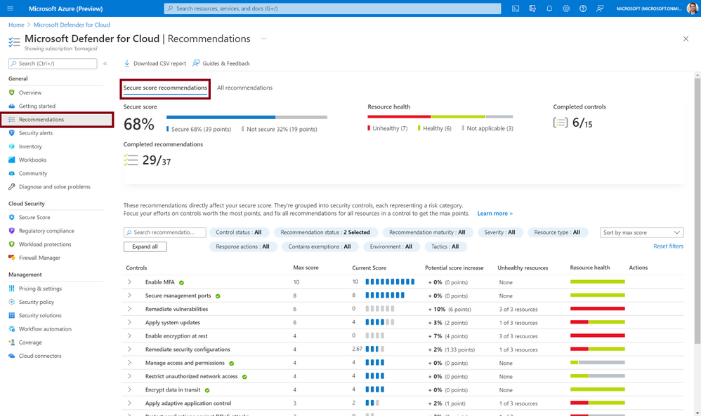*Figure 1: Secure score in Microsoft Defender for Cloud dashboard*

**View the secure score in the Azure Portal**

1. In the Azure dashboard, click Security Center and then click Secure score.
2. At the top you can see Secure score highlights:
   * The Overall secure score represents the score per policies, per selected subscription
   * Secure score by category shows you which resources need the most attention
   * Top recommendations by secure score impact provides you with a list of the recommendations that will improve your secure score the most if you implement them.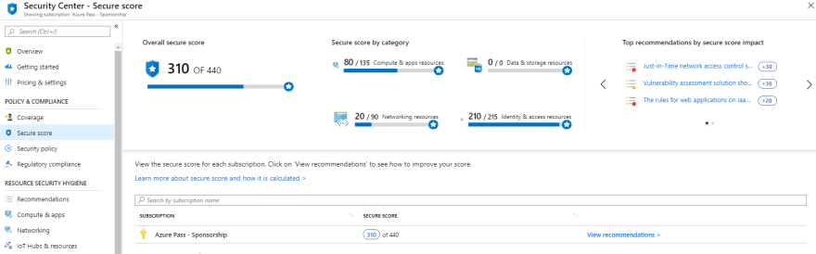
3. Click View recommendations to see the recommendations for that subscription that you can remediate to improve your secure score.
4. In the list of recommendations, you can see that for each recommendation there is a column that represents the Secure score impact. This number represents how much your overall secure score will improve if you follow the recommendations. For example, in the screen below, if you Remediate vulnerabilities in container security configurations, your secure score will increase by 35 points.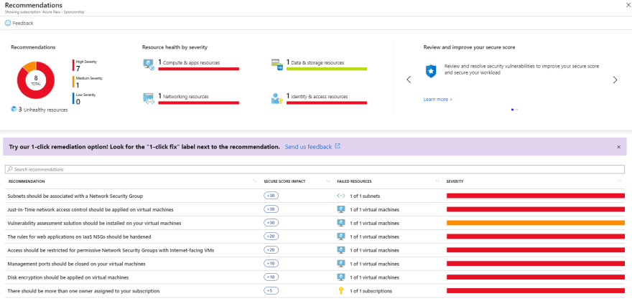

**View the individual secure scores**

In addition, to view individual secure scores, you can find these within the individual recommendation blade.  
The Recommendation secure score is a calculation based on the ratio between your healthy resources and your total resources. If the number of healthy resources is equal to the total number of resources, you get the maximum secure score of the recommendation of 50. To try to get your secure score closer to the max score, fix the unhealthy resources by following the recommendations.  
The Recommendation impact lets you know how much your secure score improves if you apply the recommendation steps. For example, if your secure score is 42 and the Recommendation impact is +3, performing the steps outlined in the recommendation improve your score to become 45.

1. Click any of the recommendations in the Secure Score blade. The recommendation shows which threats your workload is exposed to if the remediation steps are not taken.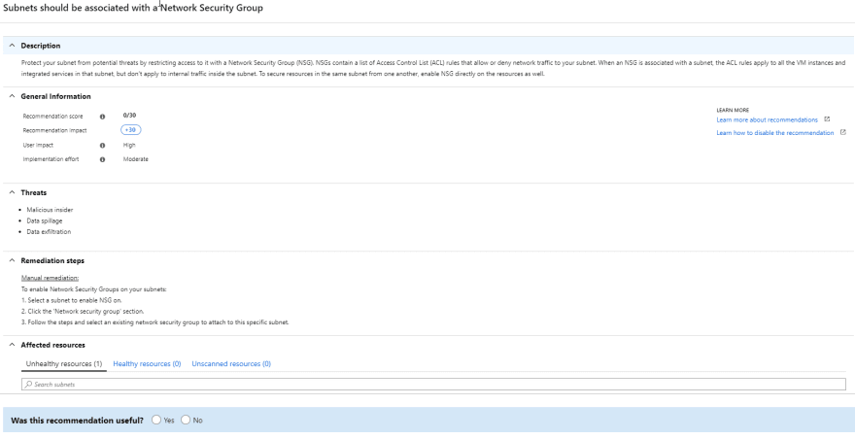

Reference links:

1. google.com/search?q=security+score+in+azure&rlz=1C1VDKB_enIN994IN994&oq=security+score+in+azure&aqs=chrome..69i57j0i390l2.40725j0j7&sourceid=chrome&ie=UTF-8
2. google.com/search?q=what+is+azure+security+score&rlz=1C1VDKB_enIN994IN994&oq=what+is+azure+security+score&aqs=chrome..69i57j0i22i30j0i390l3.20879j0j7&sourceid=chrome&ie=UTF-8
3. google.com/search?q=what+is+azure+secure+score&rlz=1C1VDKB_enIN994IN994&oq=what+is+azure+secure&aqs=chrome.1.69i57j0i512l2j0i22i30j0i390.10471j0j7&sourceid=chrome&ie=UTF-8
4. azure.microsoft.com/en-us/blog/control-and-improve-your-security-posture-with-azure-secure-score/#:~:text=Azure%20Secure%20score%20helps%20you,help%20improve%20your%20security%20posture.
5. <https://docs.microsoft.com/en-us/azure/defender-for-cloud/secure-score-security-controls>
6. <https://dev.to/cheahengsoon/secure-score-in-azure-security-center-4j4g>
7. <https://techcommunity.microsoft.com/t5/microsoft-defender-for-cloud/azure-secure-score-vs-microsoft-secure-score/ba-p/2459684>
8. docs.microsoft.com/en-us/azure/defender-for-cloud/secure-score-access-and-track
9. vulcan.io/blog/5-azure-security-tools-you-should-know-about/
10. datashieldprotect.com/blog/microsoft-azure-security-center-core-features-pricing
11. google.com/search?q=azure+posture+assessment&rlz=1C1VDKB_enIN994IN994&oq=azure+posture+assessment&aqs=chrome..69i57j0i8i30j0i390l4.17473j0j7&sourceid=chrome&ie=UTF-8
12. azure.microsoft.com/en-in/blog/strengthen-your-cloud-security-posture-with-new-capabilities-from-azure-security-center/
13. <https://www.bridewellconsulting.com/cloud-security-posture-assessment-for-microsoft>
14. google.com/search?q=azure+secure+score+pdf&source=lmns&bih=609&biw=1280&rlz=1C1VDKB_enIN994IN994&hl=en-US&sa=X&ved=2ahUKEwiY2Or7hqL3AhULi9gFHZ9-C44Q_AUoAHoECAEQAA
15. ptgmedia.pearsoncmg.com/images/9780137343423/samplepages/9780137343423_Sample.pdf
16. cdn.ttgtmedia.com/rms/pdf/MSazuresec_ch4.pdf